**Exp-2 Time Table**

**Aim:** To design a Time Table using HTML only.

**Theory:** This HTML document represents a weekly timetable for ICT-2 at PDEU, displaying classes and lab sessions across different time slots and weekdays. The timetable is structured using a table, with each row for a day and columns for specific hours, including course names, group details, and room numbers.

Tags used:

1. <div> - Groups elements together for styling or layout purposes.
2. <table> - Creates a table for displaying data in rows and columns.
3. <tr> - Defines a row in a table.
4. <th> - Defines a header cell in a table, usually bold and centered.
5. <td> - Defines a standard data cell in a table.
6. <strong> - Makes text bold, emphasizing it semantically.
7. <hr> - Adds a horizontal line to separate content (used inside <td> cells).

**Code:**

<!DOCTYPE html>

<html lang="en">

<head>

    <meta charset="UTF-8">

    <meta name="viewport" content="width=device-width, initial-scale=1.0">

    <title>ICT-2 Time Table - PDEU</title>

</head>

<body>

    <div>

        <table border="1">

            <tr>

                <th>Day</th>

                <th>8:00-9:00</th>

                <th>9:00-10:00</th>

                <th>10:00-11:00</th>

                <th>11:00-12:00</th>

                <th>12:00-1:00</th>

                <th>1:00-2:00</th>

                <th>2:00-3:00</th>

                <th>3:00-4:00</th>

                <th>4:00-5:00</th>

                <th>5:00-6:00</th>

                <th>6:00-7:00</th>

            </tr>

            <tr>

                <th>Monday</th>

                <td align="center"></td>

                <td align="center" colspan="2">Cloud Arch and Serv Lab(H4) <strong>F204</strong><hr> Emb Syst Lab(H5) <strong>E-212</strong></td>

                <td align="center">AI (H4H5H6) <strong>F-404</strong></td>

                <td align="center"></td>

                <td align="center">Emb Syst (H4H5H6) <strong>E-201</strong></td>

                <td align="center" colspan="2">DRL Lab(H4H5H6) <strong>E-212</strong><hr>ML Lab (H4H5H6) <strong>E-214</strong></td>

                <td align="center"></td>

                <td align="center"></td>

                <td align="center"></td>

            </tr>

            <tr>

                <th>Tuesday</th>

                <td align="center"></td>

                <td align="center">ML (H4H5H6) <strong>F-404</strong><hr> DRL (H4H5H6) <strong>E-202</strong></td>

                <td align="center">AI (H4H5H6) <strong>F-404</strong></td>

                <td align="center" colspan="2">Web Tech Lab (H4) <strong>E-214</strong><hr>Cloud Arch and Serv Lab (H5) <strong>E-212</strong><hr> Emb Syst Lab (H6) <strong>F-204</strong></td>

                <td align="center"></td>

                <td align="center" colspan="2">Comm Skill (H4H5H6) <strong>E-203</strong></td>

                <td align="center"></td>

                <td align="center">CDC (H4H5H6) <strong>C-201/1</strong></td>

                <td align="center"></td>

            </tr>

            <tr>

                <th>Wednesday</th>

                <td align="center"></td>

                <td align="center" colspan="2">Web Tech Lab (H5H6) <strong>E-214</strong></td>

                <td align="center">Emb Syst (H4H5H6) <strong>E-203</strong></td>

                <td align="center">CCN (H4H5H6) <strong>E-203</strong></td>

                <td align="center"></td>

                <td align="center" colspan="2">CCN Lab (H4H5H6) <strong>E-112-113</strong></td>

                <td align="center">Industry 4.0 (H4H5H6) <strong>OE Room</strong></td>

                <td align="center">Web Tech (H4H5H6) <strong>E-112-113</strong></td>

                <td align="center">ML (H4H5H6) <strong>E-201</strong><hr>DRL (H4H5H6) <strong>E-202</strong></td>

            </tr>

            <tr>

                <th>Thursday</th>

                <td align="center"></td>

                <td align="center">Cloud Arch and Serv (H4H5H6) <strong>E-201</strong></td>

                <td align="center">CCN (H4H5H6) <strong>F-404</strong></td>

                <td align="center" colspan="2">AI Lab (H4H5H6) <strong>E-112-113</strong></td>

                <td align="center"></td>

                <td align="center" colspan="2">Industry 4.0 (H4H5H6) <strong>OE Room</strong></td>

                <td align="center">Industry 4.0 (H4H5H6) <strong>OE Room</strong></td>

                <td align="center">Web Tech (H4H5H6) <strong>E-204</strong></td>

                <td align="center"></td>

            </tr>

            <tr>

                <th>Friday</th>

                <td align="center"></td>

                <td align="center">AI (H4H5H6) <strong>E-201</strong></td>

                <td align="center">CCN (H4H5H6) <strong>E-203</strong></td>

                <td align="center">Emb Syst (H4H5H6) <strong>E-203</strong></td>

                <td align="center"></td>

                <td align="center">Cloud Arch and Serv (H4H5H6) <strong>E-201</strong></td>

                <td align="center" colspan="2">Cloud Arch and Serv (H6)  <strong>E-212</strong><hr> Emb Syst Lab (H4) <strong>F-204</strong></td>

                <td align="center">CDC (H4H5H6) <strong></strong>OE Room</td>

                <td align="center"></td>

                <td align="center"></td>

            </tr>

        </table>

    </div>

</body>

</html>

**Output:**

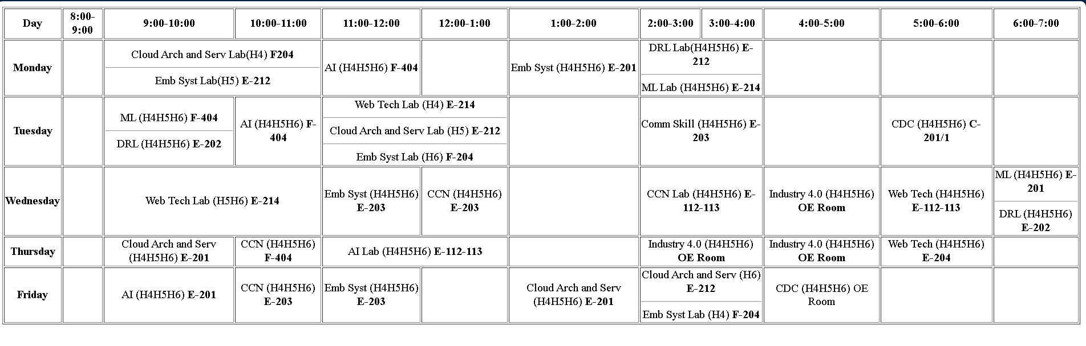

After css:

